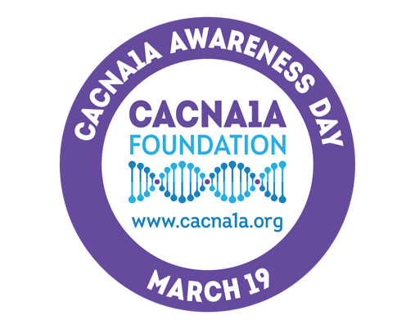

CACNA1A Awareness Day

March 19, 2023

- Message to a public official – please personalize and make it your own.
- A Proclamation template follows.
On behalf of my family and the hundreds of other families who have had their lives affected by the rare disease CACNA1A, I am writing to request that a proclamation be issued this year for CACNA1A AWARENESS DAY, which is on March 19, 2023.
The CACNA1A gene encodes for the P/Q type calcium channel in the brain, which controls calcium entry into neurons. Genetic mutations on the CACNA1A gene disrupt this calcium entry, leading to various symptoms, including epilepsy, autism, global developmental delay, intellectual disability, movement and balance disorders, eye movement disorders and hemiplegic migraines, stroke-like episodes. CACNA1A is one of the genes commonly associated with medication-resistant epilepsy.
CACNA1A can be passed from parent to child, but most cases occur because of a random spontaneous mutation called a de novo mutation. In other words, it can affect anyone. There are currently no treatment options and no cures.
As a rare disease, raising awareness is one of our greatest tools in the fight to find a cure. With your support in declaring March 19th CACNA1A AWARENESS DAY, we can continue to increase awareness about this neurodegenerative disease. Knowledge is power and as a decision-maker with your office's extraordinary reach and respect, we are confident that this acknowledgment from you will help bring us one step closer to finding new therapeutics and even a cure.
Please find below a draft of a proposed Proclamation for CACNA1A AWARENESS DAY on March 19^{th.}
Thank you for your time and consideration on behalf of all families affected by this devastating disorder. Together, we will end CACNA1A!

CACNA1A Awareness Day

March 19, 2023

WHEREAS it is the custom of this Legislative Body to recognize official days to increase awareness of serious illnesses that affect the lives of citizens of (STATE NAME HERE), such as genetic variants on the CACNA1A gene; and

WHEREAS a diagnosis of a genetic variant on the CACNA1A gene means an individual could have neurodevelopmental differences, epilepsy, ataxia, migraines, cerebellar atrophy and eye movement disorders; and

WHEREAS CACNA1A is a gene located on the short arm of the 19th chromosome that plays a vital role in the communication between neurons in the brain, and a change in the gene alters the function of the calcium channels affecting the release of neurotransmitters; and

WHEREAS individuals with a variant on the CACNA1A gene can experience life-altering neurological emergencies of a hemiplegic migraine attack, stroke, coma, seizure emergencies, and cerebral edema; and

WHEREAS treatment options for individuals with a CACNA1A gene variant are limited to treating symptoms only with medications and diet, there is no cure; and

WHEREAS it is imperative that there be greater public awareness of this health issue, and more must be done to increase activity at the local, state and national levels.

NOW, THEREFORE, as Governor of the State of (STATE NAME), I do hereby proclaim March 19, 2023, CACNA1A AWARENESS DAY in the State of (STATE NAME).

Signature: ________________________________________________ Date: ___________________

